PulseWatch v2 — Project Status
Updated: June 9, 2026

Project Overview
PulseWatch is a self-hosted uptime and status dashboard. It monitors HTTP and TCP services and shows live status, response times, sparklines, SSL certificate health, check history, and incident tracking — all in a single-page app with no npm dependencies.

GitHub: github.com/jerryhobson-datageek/plusewatch
Stack: Node.js 22, stdlib only + node:sqlite (built-in). Vanilla JS frontend, no frameworks.
Live server: srv1681739.hstgr.cloud (Hostinger VPS, Ubuntu 24.04 LTS)
Service URL: https://plusewatch.newtekk.com
Local path: C:\claudcode

Architecture

Files
- server.js — Node.js backend — all API routes, monitoring logic, SQLite ops
- index.html — Single-file frontend — all HTML, CSS, and JS
- config.json — Services list, credentials (scrypt hashed), alert webhooks, port, intervals
- maintenance.json — Scheduled maintenance windows
- history.db — SQLite database — check history + incident log (30-day retention)

Server Layout (VPS)
- /root/plusewatch/ — Git clone — pull updates here
- /opt/pulsewatch/ — Running copy — what systemd executes
- /etc/systemd/system/pulsewatch.service — Systemd unit file, runs as www-data

Deployment Workflow
1. Commit and push changes to GitHub (main branch)
2. SSH to server and git pull in /root/plusewatch/
3. Copy server.js and index.html to /opt/pulsewatch/ (never overwrite config.json or maintenance.json)
4. systemctl restart pulsewatch

Screenshots

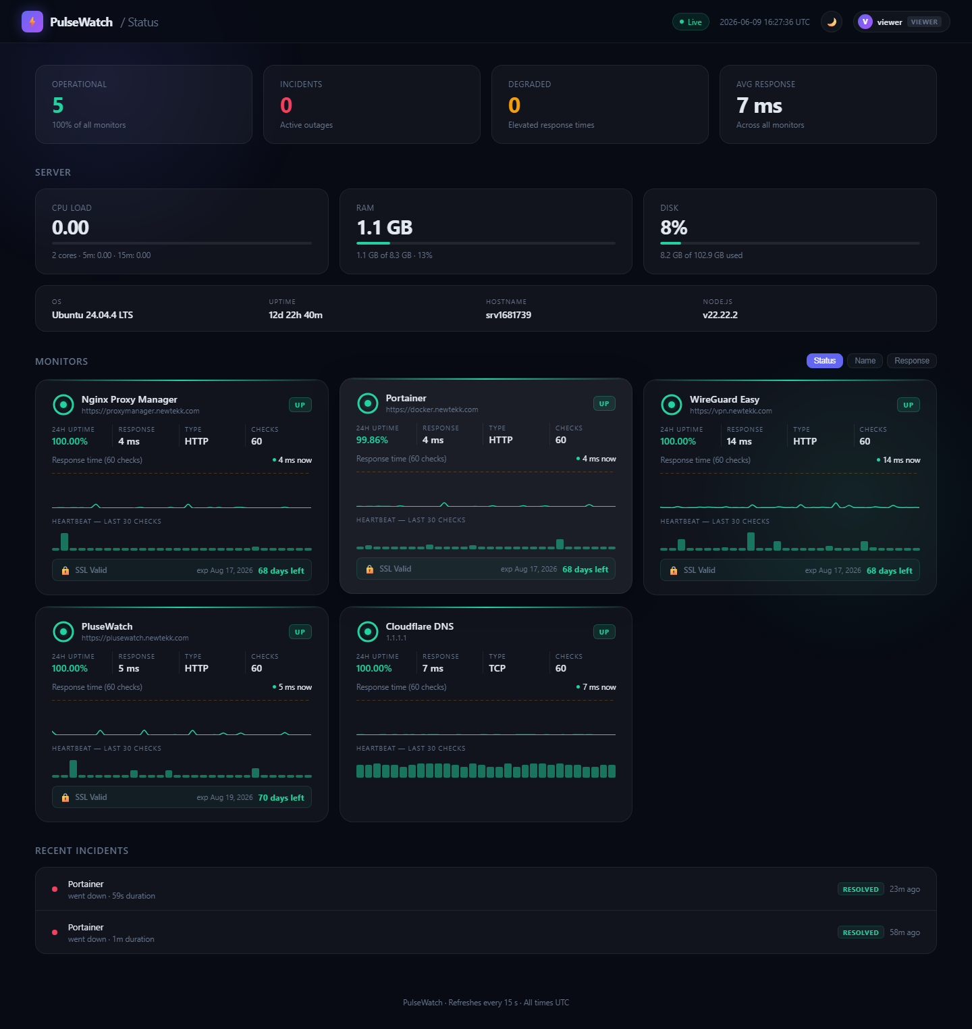
Dashboard — dark mode

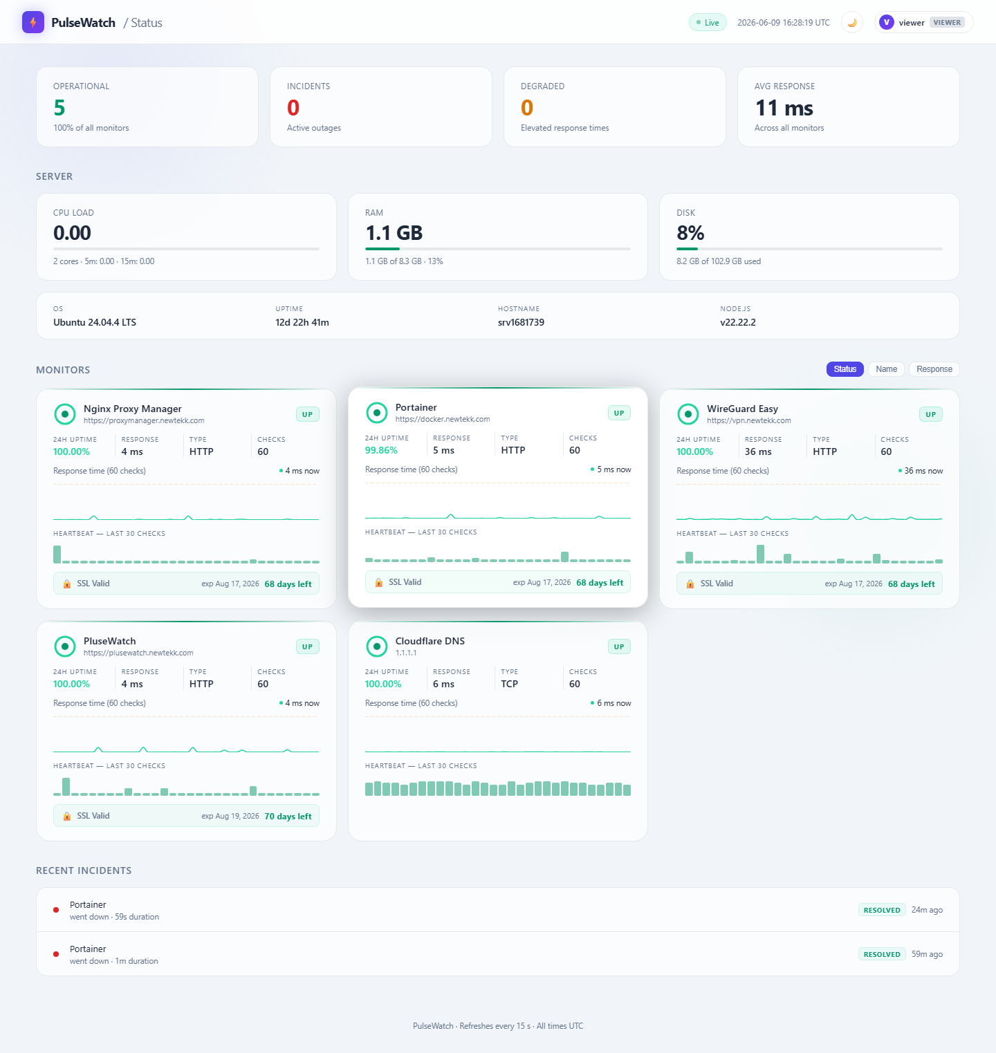
Dashboard — light mode

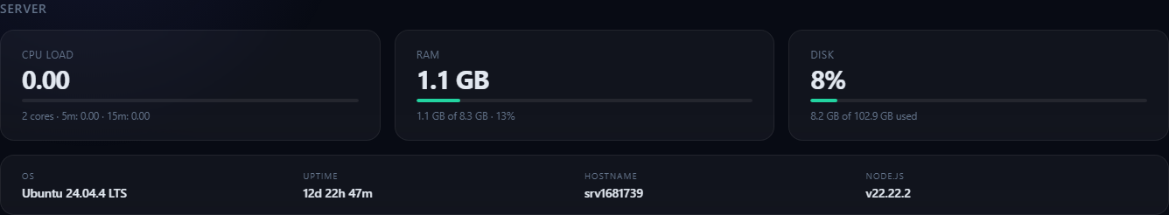
Server stats — CPU load, RAM, disk usage, OS, uptime, and hostname

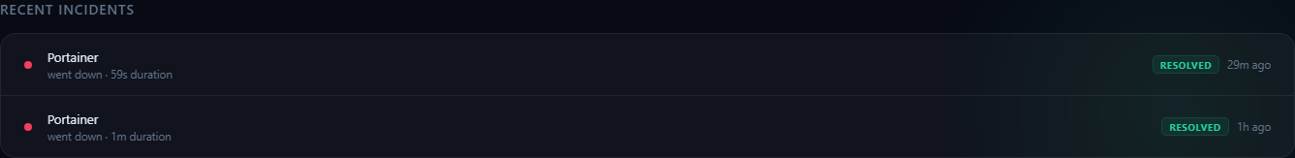
Incident log — service outages with duration and resolved/ongoing status

Features Built

1. Authentication & Role-Based Access
- ✅ Login screen overlay before dashboard loads
- ✅ Admin role — manage services, schedule maintenance, configure alerts
- ✅ Viewer role — read-only dashboard, sees status and maintenance notices
- ✅ Session tokens via crypto.randomBytes, 24-hour TTL in sessionStorage
- ✅ Passwords hashed with crypto.scryptSync, stored in config.json
- ✅ Change password via UI (each user can change their own)
- ✅ Default credentials auto-generated on first run (admin/admin123, viewer/viewer123)

2. Service Monitoring
- ✅ HTTP/HTTPS checks — GET request, status 200–399 = up
- ✅ TCP checks — raw socket connect
- ✅ Per-service check interval (default 30s, configurable per service)
- ✅ Degraded threshold — marks service yellow if response time exceeds limit (ms)
- ✅ Staggered startup — services start 600ms apart to avoid thundering herd

3. SSL Certificate Monitoring
- ✅ Checks HTTPS services every 6 hours via TLS socket
- ✅ Warning at 30 days remaining, critical at 7 days, expired state
- ✅ SSL badge on each monitor card showing days remaining and expiry date
- ✅ Discord alert on SSL status change to warning/critical/expired

4. Check History & Uptime (SQLite)
- ✅ All checks persisted to history.db (SQLite via node:sqlite built-in)
- ✅ 30-day retention with daily pruning
- ✅ History modal — click any monitor card to view 24h / 7d / 30d charts
- ✅ Charts show avg response time, uptime heatmap, uptime %, avg/max RT, total checks
- ✅ 24h uptime % shown on each monitor card (from SQLite, not rolling buffer)

5. Incident Log
- ✅ Server-side incident detection on status transitions in runCheck()
- ✅ incidents table in SQLite — started_at, resolved_at, duration_ms per incident
- ✅ Open incidents restored from DB on server restart
- ✅ Dashboard shows recent incidents with service name, action, duration, Resolved/Ongoing badge
- ✅ Incident list is DB-backed — persists across page reloads

6. Maintenance Windows
- ✅ Admin can schedule maintenance per service: title, start, duration, description
- ✅ Stored in maintenance.json (not overwritten on deploy)
- ✅ During window: service shows grey Maintenance status, alerts suppressed
- ✅ Sticky banner at top of dashboard for all active windows with countdown
- ✅ Schedule Maintenance button on each monitor card (admin only)
- ✅ Maintenance windows list with Active / Upcoming / Completed status badges

7. Webhook Alerting
- ✅ Webhook notifications on Down, Degraded, and Recovery status changes
- ✅ Discord format auto-detected (rich embeds with color-coded status)
- ✅ Generic/Slack-compatible JSON payload for other webhooks
- ✅ Per-service cooldown (default 300s) prevents spam on flapping services
- ✅ Recovery alerts include actual response time (e.g. "6 ms") confirming health
- ✅ Down alerts show "—" for response time (connection-refused timing is noise)
- ✅ Admin UI — add/edit/delete/toggle/test webhooks without SSH
- ✅ Test button sends labelled test payload and shows success/failure toast
- ✅ Discord webhook configured: id=discord01, all 3 events, stored in config.json

8. Admin Service Editor
- ✅ Add, edit, and delete monitored services from the dashboard UI
- ✅ Fields: name, URL, type (HTTP/TCP), interval, degraded threshold
- ✅ New services start monitoring immediately without server restart
- ✅ Services list with live status dots (admin only section)

9. Server Stats Section
- ✅ Live CPU load average (1m / 5m / 15m) with utilisation bar
- ✅ RAM used/total with percentage progress bar
- ✅ Disk used/total with percentage progress bar
- ✅ Bars colour green < 70%, yellow 70–90%, red > 90%
- ✅ Info row: OS (Ubuntu 24.04.4 LTS), system uptime, hostname, Node.js version
- ✅ Polls every 15 seconds alongside service checks
- ✅ OS name read from /etc/os-release at boot for clean display

10. Dashboard UX
- ✅ Dark / light mode toggle, preference saved to localStorage
- ✅ Live clock in header (UTC)
- ✅ Status ring on each card driven by 24h uptime % (SQLite-backed)
- ✅ Sparkline chart per service with degraded threshold reference line
- ✅ Heartbeat bar — last 30 checks visualised as coloured bars
- ✅ Sort monitors by Status / Name / Response time
- ✅ Summary grid — Operational count, Incidents, Degraded, Avg Response
- ✅ Toast notifications on status changes (live, in-browser)

Services Currently Monitored
- Nginx Proxy Manager — https://proxymanager.newtekk.com | HTTP | 1000ms degraded
- Portainer — https://docker.newtekk.com | HTTP | 1000ms degraded
- WireGuard Easy — https://vpn.newtekk.com | HTTP | 1000ms degraded
- PulseWatch — https://plusewatch.newtekk.com | HTTP | 1000ms degraded
- Cloudflare DNS — 1.1.1.1 | TCP | 60s interval, 1000ms degraded

Remaining / Future Features

From Original Roadmap — Not Yet Built
- ⬜ PING check type (third check type alongside HTTP and TCP)
- ⬜ Response keyword matching — confirm specific text in HTTP response body
- ⬜ Consecutive failure threshold — only alert after N failures in a row

Potential Enhancements
- ⬜ Email alerting via SMTP (complement to webhook alerting)
- ⬜ Public status page — unauthenticated read-only view for sharing with users
- ⬜ Admin user management UI — add/remove users without editing config.json
- ⬜ Multi-server support — monitor services across multiple hosts
- ⬜ Notification for SSL cert changes detected during 6-hour checks

Updated by Claude Code (claude-sonnet-4-6) — June 9, 2026

